A

Project Report

On

“Centralized Information System of BHILAI NIWAS”

Submitted to

CHHATTISGARH SWAMI VIVEKANAND TECHNICAL UNIVERSITY,

BHILAI

In partial fulfillment of requirement for the award of degree

Of

Bachelor of Engineering

In

Information Technology

By
Jitin Bhatia

Ashish Kumar Ray
Roshni Saraogi

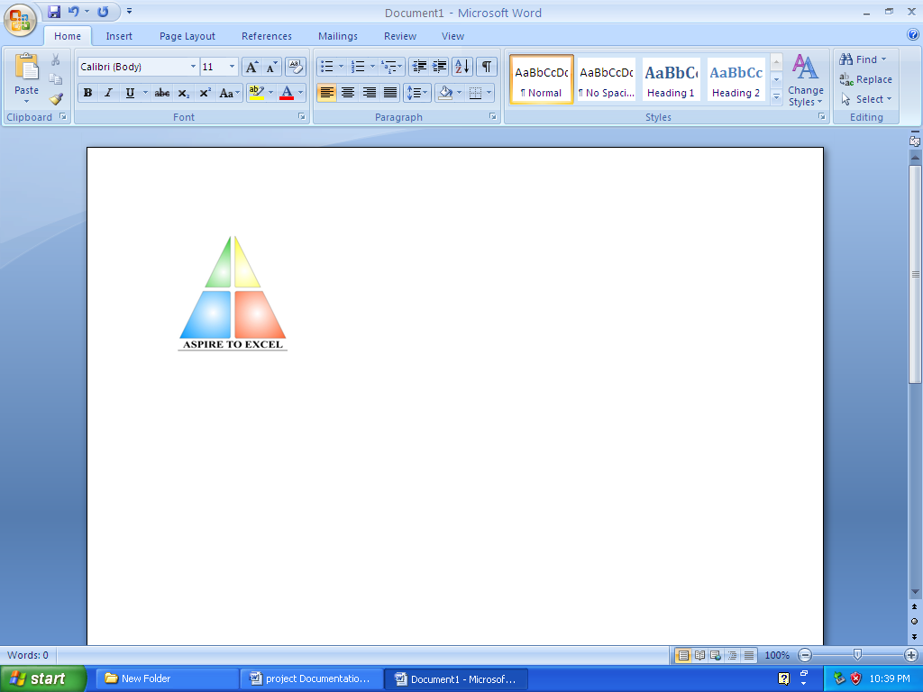

Department of Information Technology,Bhilai Institute of Technology, Bhilai House, Durg, Chattisgarh -491001.

Session: 2006-2010

CERTIFICATE

This is to certify that the report of the project submitted is an outcome of the project work entitled “Centralized Information System for BHILAI NIWAS” carried out by
SNO | NAME OF STUDENT | ROLL NO | ENROLLMENT NO
1. | ASHISH Kr. RAY | 3013306011 | AA9824
2. | JITIN BHATIA | 3013306017 | AA9842
3. | ROSHNI SAROAGI | 3013306035 | AA9921

Carried out under my guidance and supervision for the award of Degree in Bachelor Of Engineering in Information Technology of Chhattisgarh Swami Vivekanand University , Bhilai (C.G) , India .

To the best of my knowledge the report
- Embodies the work of the candidate him/herself ,
- has duly been completed,
- Fulfils the requirement of the Ordinance relating to the B.E. degree of the University and
- Is up to the desired standard for the purpose of which is submitted.

____________________
(Signature of the Guide) Name of Guide : Amrendra Singh Designation : Lecturer Department : I.T. Institute : B.I.T., DURG
The project work as mentioned above is hereby being recommended and forwarded for examination and evaluation.
(Signature of HOD with seal ) _______________________________

CERTIFICATE BY THE EXAMINERS

This is to certify that the project work entitled

“Centralized Information System for BHILAI NIWAS”

Submitted by
SNO | NAME OF STUDENT | ROLL NO | ENROLLMENT NO
1. | RYAN KARAK | 3013306037 | AA9824
2. | SAPTORSHI DAS | 3013306041 | AA9966
3. | SUYASH SONI | 3013306055 | AB0073

has been examined by the undersigned as a part of the examination for the award of Bachelors of Engineering degree in <Name of Branch> of Chhattisgarh Swami Vivekanand University , Bhilai (C.G) .

___________________ ___________________
Internal Examiner External Examiner
Date: Date:

ACKNOWLEDGEMENT

Working on this project has been a great learning experience for us. There were moments of anxiety, when we could not solve a problem for several days and there were moments when we could solve a problem after struggling for several days. But we have enjoyed every bit of the process and are thankful to all people associated with us during this period.

We convey our sincere thanks to our project guide Mr. Amrendra Singh, for providing us all sorts of facility. His support and guidance helped us to carry out the project. I owe a great debt of his gratitude for his constant advice, support, co-operation and encouragement throughout the project.

We would like to express our deep gratitude to respected H.O.D Information Technology Department Mrs. Arpana Rawal madam for her helpful solutions and comments enriched by experience, which improved our ideas for betterment of project.

It will be our pleasure to acknowledge, utmost co-operation and valuable suggestion from time to time given by Mr. Raj Kumar Sharma (Project In-Charge), Mr. Sumit Ghosh, Globusoft STPI) and other staff members of Information Technology department, to whom we owe our entire computer knowledge and also we would like to thank all those persons who have directly or indirectly helped us by providing books and computer peripherals, and other necessary amenities which helped in the development of this project which would otherwise have not been possible.

_______ ________ ________
(Ryan Karak) (Suyash Soni) (Ashish Kr. Ray)

Information Technology, 7th Semester
Bhilai Institute of Technology, Bhilai House, Durg, Chattlsgarh-491001

